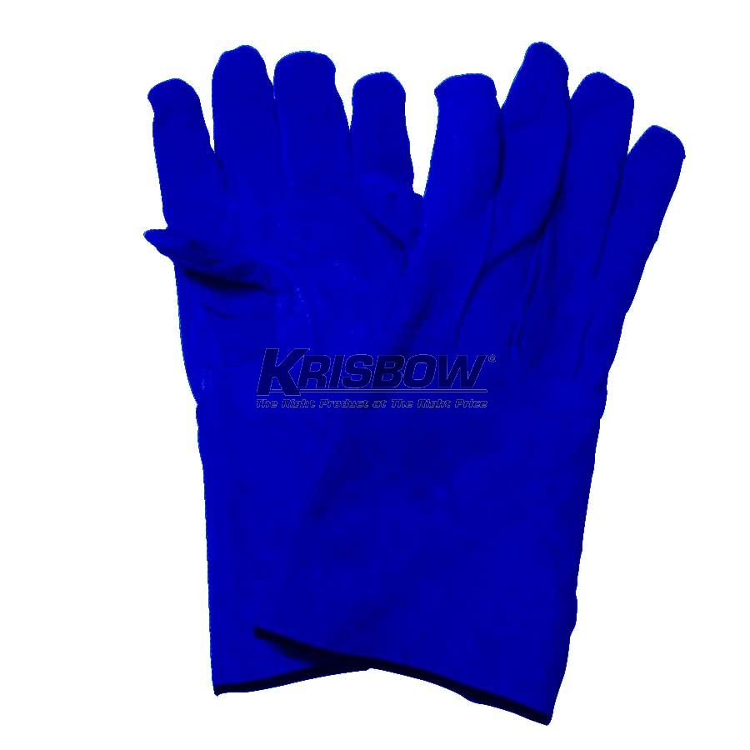

Welding Glove, 16” Blue Leather
Category: Personal Protective Equipment / Hand Protection/Gloves / Welding Gloves
Description:
(SOLD AS PER PAIR)

- Split cow hide blue leather
- Thumb design suitable for holding
- Internal lining to reduce heat
- 41cm for hand and forearm protection
- Gauntlet cuffs protects the forearm from welding splash
- One size fits all
- Arc welding, general purpose

